Final Project Analysis With JMP

Analyst: Feifei Li

EDA (Deleted the 3 missing data )

Explore distributions of all variables

Identify extreme right-skew in charges

Inspect categorical patterns (sex, region, smoker)

Check scatterplots → BMI × smoker separation

Confirm no multicollinearity among numeric variables

Evidence suggests interaction & log-transform likely

Exploring the quantitative data (age, bmi, children, charges)
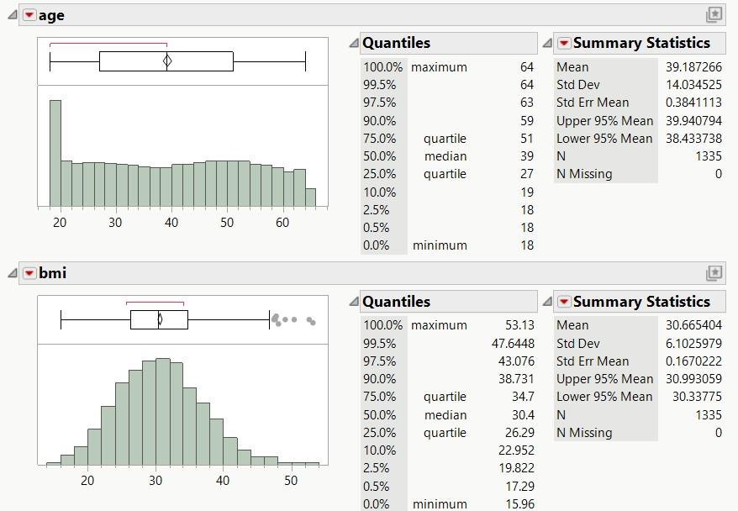
- Age
Range: 18 to 64
Median: 39
Mean: 39.19
Shape: Slight right-skew
Outliers: None
Interpretation:
The age distribution is fairly uniform across adulthood, with no extreme outliers. This suggests enough variation across ages to detect age effects in the regression model.
- BMI
Range: 15.96 to 53.13
Median: 30.4
Mean: 30.67
Shape: Slight right-skew
Outliers: Several BMI values above ~45 appear as legitimate high-BMI individuals
Interpretation:
Most individuals fall around BMI 25–35 (overweight to obese), with a few naturally high-BMI cases. These are not data errors and should not be removed. Because BMI spreads well across the sample, it is expected to be an important predictor of charges.
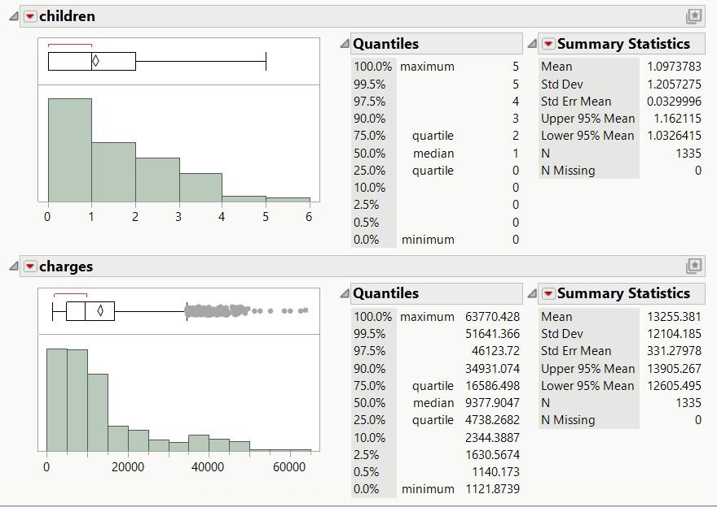
- Children
Range: 0 to 5
Median: 1
Mean: 1.10
Shape: Highly right-skewed / discret
Most common values:
0 children → very common
1–2 children → moderate
3–5 children → rare
Interpretation:
The children variable is heavily skewed toward fewer dependents. This variable should still be included, but its effect is likely smaller than age, BMI, or smoker. The lack of symmetry is not a problem because children is a predictor, not a response.
4. Charges
Range: 1,121.87 to 63,770.43
Median: 9,377.90
Mean: 13,255.38
Shape: Strong right-skew (very heavy tail)
Outliers: Many high-cost observations (especially > $30,000)
Interpretation:
Charges are very right skewed with a long tail. This is typical because a small subset of people incur extremely high medical expenses—especially smokers and individuals with high BMI.
This strong skew supports:
Using residual diagnostics; Considering log(charges) transformation if the residuals show heteroscedasticity or non-normality (very likely)
The quantitative variables show a mixture of symmetric and right-skewed distributions. Age and BMI are moderately right-skewed but overall well-behaved. The 'children' variable is discrete and heavily skewed toward lower values, but this is expected for count data. The most notable feature in the dataset is that the response variable, charges, is strongly right-skewed with many high-cost outliers. These values are legitimate medical expenses and should not be removed. The strong skew suggests that a log transformation may be needed to meet linear model assumptions.

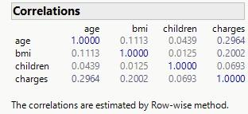
Check for the multicollinearity ( for the quantitative data)

age vs bmi ≈ 0.11 bmi vs children ≈ 0.01 age vs children ≈ 0.04
No correlated predictors → no multicollinearity risk.

2.Exploring the qualitative data( sex, smoker, region)
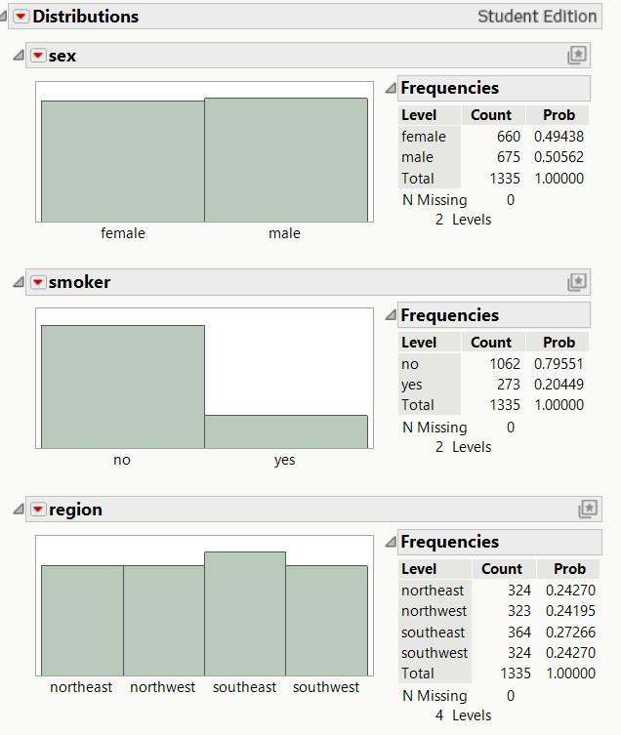
The distributions show that frequency counts, proportions, and bar charts.
- the dataset is balanced (sex, region)
- smoker variable is imbalanced (only 20% smokers)
- some categories are more common (SE region)
These patterns matter for regression interpretation and interaction effects.

3.Explore relationships
Bar charts : charges vs smoker
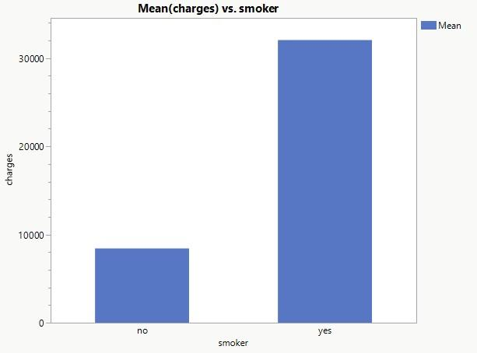
The graph shows that the smoker’s charges are much higher, it indicates that interaction BMI
* smoker is necessary , smoker is a key predictor
Boxplot : charges vs sex
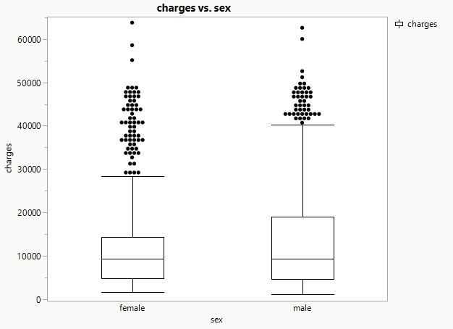
The distributions of charges for males and females are very similar. The medians are nearly the same, and the interquartile ranges (IQRs) overlap substantially, indicating comparable variability in typical charges for both groups. While the male group shows slightly larger spread, these differences are small relative to the overall variability in charges. Both groups exhibit many high-cost outliers extending to similar levels. Overall, there is no strong visual evidence that sex has a substantial effect on health insurance charges.
Boxplots : Charges vs smoker, sex, region
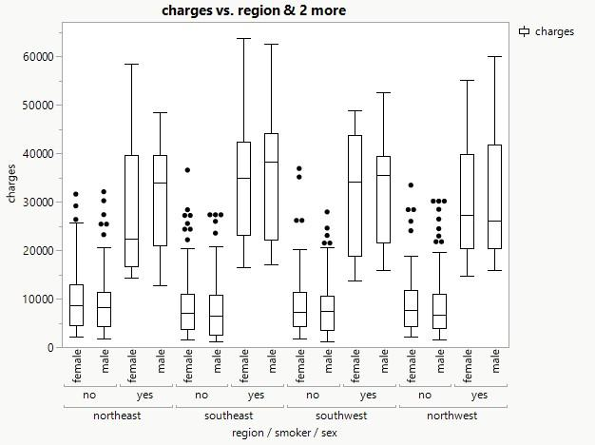
It shows that smokers always have much higher charges. Smoking is by far the strongest categorical driver of medical charges. Region does not show major differences in charges.
Sex is not a strong predictor of charges.
The combined boxplot comparing charges across region, smoker status, and sex reveals clear and consistent patterns. Across all four regions, smokers have substantially higher medical charges than non-smokers, with much higher medians, wider interquartile ranges, and more extreme outliers. This confirms smoking as the strongest categorical predictor in the dataset. In contrast, the differences among regions are relatively small, with similar medians and spreads across Northeast, Northwest, Southeast, and Southwest. Male and female distributions also overlap heavily within each region and smoking group, suggesting that sex has little influence on charges. Overall, smoking dominates the variation in medical costs, while region and sex show minor effects.

4.Check Scatterplots for potential interactions
C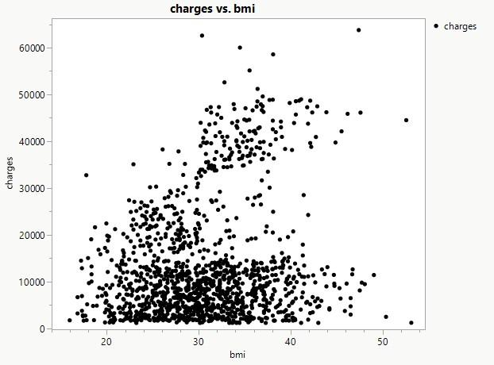harges vs BMI
Scatterplot charges vs age
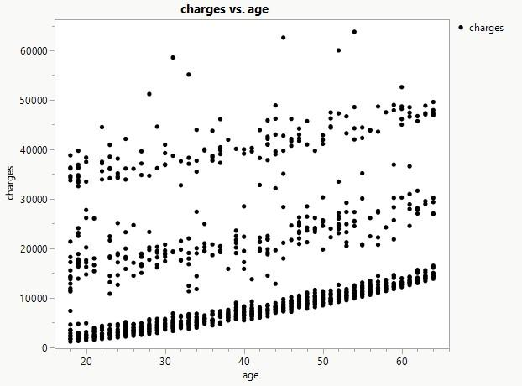
Charges vs BMI colored by smoker
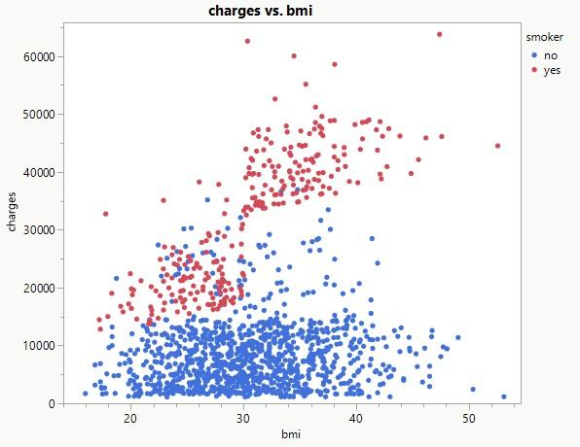

EDA FINDINGS
Numerical Summary
Age, BMI, and charges show typical skew patterns. Charges are strongly right-skewed with a long upper tail, suggesting that a log transformation may improve normality and stabilize variance.
Categorical Comparisons
Smokers display dramatically higher charges compared to non-smokers, indicating a strong main effect. Regions show moderate differences, and sex shows only small variation.
Scatterplots
Charges increase with age and BMI, but the rate of increase appears much steeper among smokers. This visual pattern supports including a BMI × smoker interaction in the regression model.
Correlation
Age and BMI are weakly correlated, reducing multicollinearity risks. Charges correlate moderately with BMI and strongly with smoker status.
Initial Findings
Charges skewed → may need log transform
Smokers have much higher charges
Visual interaction between BMI and smoker
No strong multicollinearity

VARIABLE SCREENING

Run Stepwise
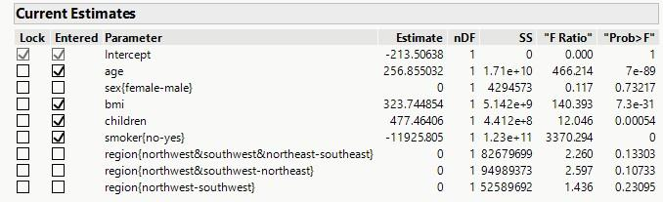
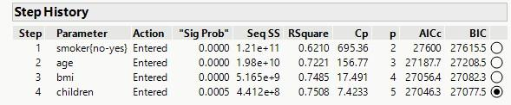
These 4 predictors survived Stepwise screening → meaning they were statistically useful for predicting charges.
Sex and region dummy variables (3 region categories)
Stepwise tested them but rejected them—they did not improve AIC/BIC/p-values enough to stay in the model.

All Possible Models
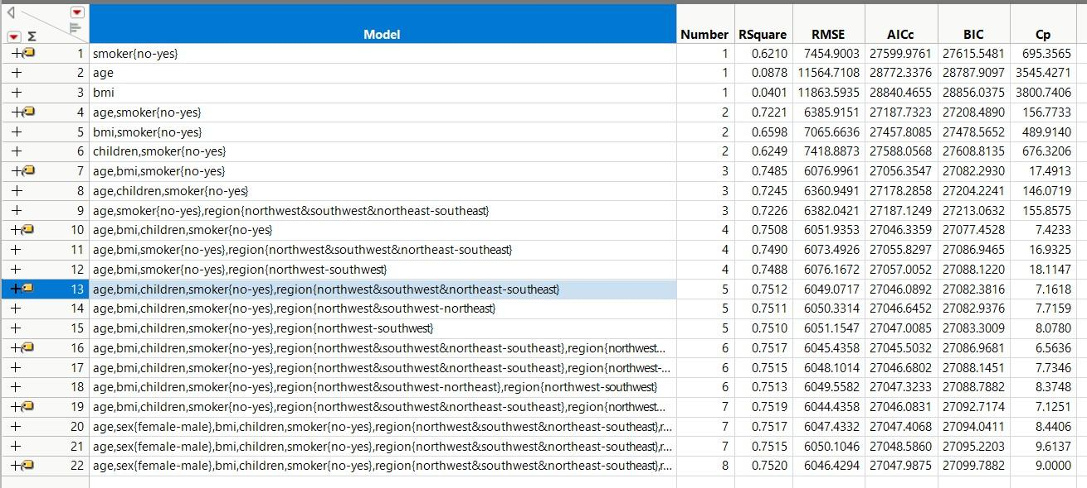
As the carefully compared all the critical numbers , we also choose for the Model 10 as these 4 variables as the best model.
Because it has very high R² and excellent Cp; the lowest or nearly lowest AICc ; lowest complexity; Region and sex add complexity without improving fit. This is the “simplest model nearly as good as full model”

Stepwise Screening Conclusion
Stepwise regression (mixed direction, AICc stopping rule) selected age, BMI, children, and smoking status as important predictors of insurance charges. The variables sex and region were evaluated but not retained due to non-significant contribution to the model. Smoking status had the largest effect, increasing average charges by approximately $12,000, followed by BMI and age. The selected subset forms a strong and interpretable starting model for the final regression analysis.

CONCLUSION
Exploratory analysis revealed that charges are heavily right-skewed with many high-cost cases, primarily among smokers and people with high BMI. Age, BMI, and number of children showed clear positive associations with charges, while smoker status exhibited the strongest separation between groups. In contrast, sex and region displayed little to no difference in charge distributions. Correlation analysis confirmed weak relationships among predictors and ruled out multicollinearity.
Stepwise regression supported these findings by selecting age, BMI, children, and smoking as the most important predictors, while rejecting sex and region due to their limited contribution to the model. Smoking had the largest estimated effect, followed by BMI and age. The resulting subset aligns with the EDA and provides a well-supported foundation for Model 1 .

Model 1:

This model includes only the main effects
E(y) = β0 +β1x1+β2 x2+β3x3+β4x4 Where x₁= age
x₂ = bmi
x₃ = children
x₄ =smoker[no]
Smoker Type (2 levels: yes(baseline), no)
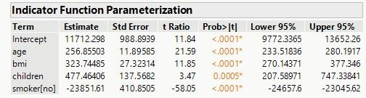

E(y) = 11712.298+ 256.85503x₁+ 323.74485x₂+477.46406x₃ -23851.61x₄
β1= 256.86, age, p < .0001: For each additional year of age, expected charges increase by about $256.86, holding all other variables constant.
Β2 = 323.74, bmi, p < .0001: Each 1-unit increase in BMI is associated with an increase of approximately $323.74 in expected charges.
Β3 = 477.46, children, p = 0.0005: Each additional dependent increases expected charges by about $477.46.
β4 = –23851.61,Smoker (no vs yes), p < .0001): Non-smokers have $23851.61 lower charges than smokers on average.
This is the largest and most significant effect in the model.
Interpretation of Coefficients (Model 1).
Using indicator coding with smokers as the reference group, age, BMI, number of children, and smoking status were all statistically significant predictors of medical charges. Controlling for other variables, each additional year of age increased expected charges by approximately $257, while each one-unit increase in BMI increased charges by about $324. Each additional child raised annual charges by roughly $477. Smoking had by far the largest effect: non-smokers had approximately $23,852 lower charges than smokers, indicating that smokers incur dramatically higher medical costs compared to non-smokers.

1. Global F-test (Overall Usefulness)
Conduct the global F-test of model useful at the α = 0. 05 level of significance.
𝐻0: 𝛽1 = 𝛽2 = ⋯ = 𝛽4= 0 𝑣𝑠 𝐻𝑎: 𝐴𝑡 𝑙𝑒𝑎𝑠𝑡 𝑜𝑛𝑒 𝑜𝑓 𝑡ℎ𝑒 𝛽𝑖 ≠ 0 i= 1 to4
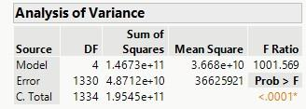
F =1001.569 , p_value = 0.0001 < 0.05, reject the 𝐻0 . The data provides strong evidence that at least one of the model coefficients is nonzero. The overall model appears to be statistically useful for predicting charges.

2.Inferences About the Individual 𝛽 Parameters( T-test for individual )
Predictor | Estimate | p-value | Significant?
Intercept | 11712.30 | <.0001
Age | 256.86 | <.0001 | Yes
BMI | 323.74 | <.0001 | Yes
Children | 477.46 | 0.0005 | Yes
Smoker (no) | –23851.61 | <.0001 | Yes (strongest)

3. Perform all diagnostics

Model Evaluation
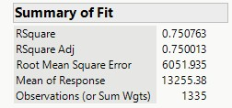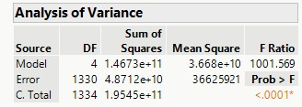

The estimator of σ² is 𝑠² = 36625921 is the Mean Square for Error (MSE) estimated standard error of the regression model: s = RMSE = 6051.94
We expect the model to provide predictions of charges to within about ± 2𝑠 = ±12, 103. 88dollars.
The RMSE of 6046.429 indicates that typical prediction errors are about $6,046. Since prediction error is approximately ±2×RMSE, we expect predictions to vary by roughly ±$12,103.88around the fitted line

Measure of Model Adequacy
The Adjusted 𝑅² = 0.7508 , 75.08% of the total variatin in charges y is explained by the model with variables age , sex,bmi, children,etc , adjusting for the sample size and the number of vairables in the Model1.

Check Practical Utility using Coefficient of Variation (CV)
CV=6051.94/13255.38×100≈45.66%
The desired rule of thumb is that regression models should have a CV of 10% or smaller. Since the calculated CV is 45.66%, the value of s is likely too large relative to the mean of the dependent variable. Even though the model is statistically useful (high F-ratio), it is considered undesirable for practical use in predicting the absolute dollar value of charges,. This finding strongly suggests that a transformation of the dependent variable (y) is necessary to reduce prediction error, confirming the EDA suggestion to consider ln(charges)

Residual Diagnostics
The residual by predicted plot
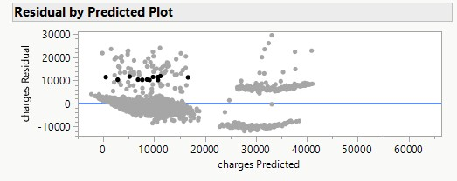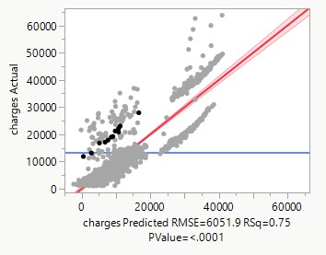

The residual by predicted plot shows two distinct horizontal bands of residuals separated around predicted charges of $20,000. Within these bands, the variability of the upper band (high predicted charges) is visibly much greater than the lower band. This pattern, where the size of the residuals varies across the range of ^y(not showing a random, consistent width), is a strong indicator of heteroscedasticity (unequal variances)
When the variance increases with the mean response (as suggested by the wider spread at higher predicted charges), it indicates that a multiplicative model may be appropriate. This means transforming the response variable, y, often using the natural logarithm (ln(y)), is necessary to stabilize the variance .
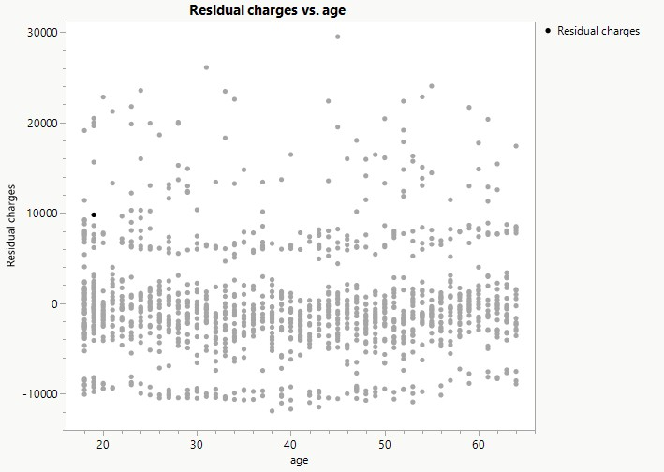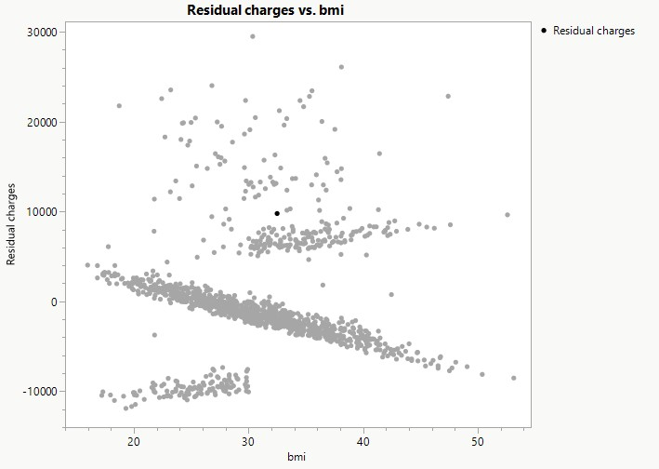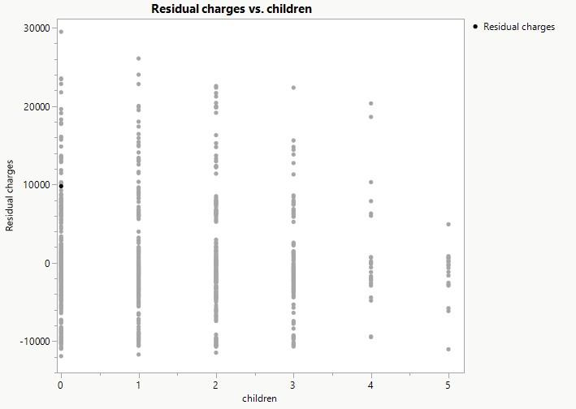

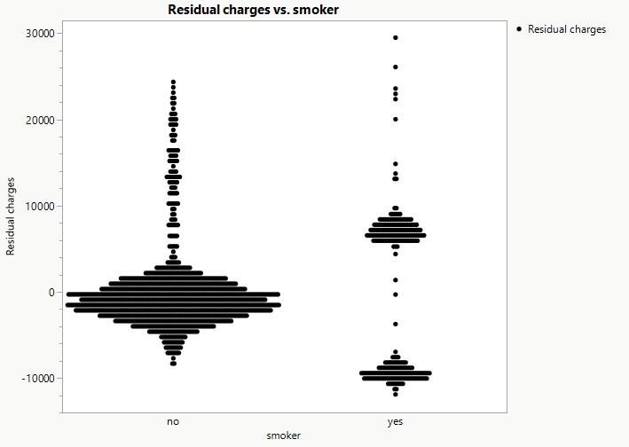
The Residual charges vs. bmi plot clearly shows two distinct fan-shaped patterns (a large, positive cluster and a smaller, negative cluster), rather than a random scatter. This structure indicates that the linear model is misspecified and that the effect of BMI depends significantly on some other variable in the model (almost certainly the smoker variable, which creates two populations). This strongly suggests the need for an interaction term.

Normality diagnostics

Residual Histogram
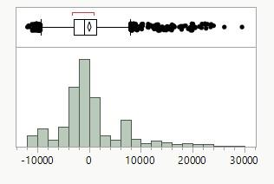
It shows that the distribution is heavy tailed right skewed with outliers as well , the normality assumption would be violated.
Normal Probability Plot
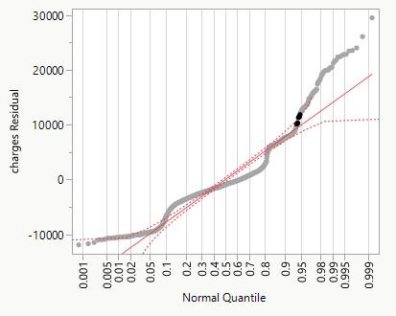
The QQ plot shows a severe S-shaped deviation from the diagonal line, particularly at both tails (residuals dropping sharply negative at the low end and curving sharply positive at the high end). This pattern confirms that the residual distribution is highly right-skewed and not normal, which is a severe violation of the normality assumption A nonliear trend indicates that the normality assumption is most likely violated.

Sharpiro-Wilk Test
𝐻0: The probability distribution of ε is normal
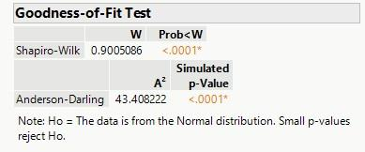
𝐻𝑎: The probability distribution of ε is not normal

P_vaule <0.0001 < 0.05 , reject the 𝐻0. There is significant evidence that probability distribution of ε is not normal.

Residual diagnostics for the updated Model 1 (including age, BMI, children, and smoker only) reveal substantial violations of regression assumptions. The residual-by-predicted plot shows a clear pattern of heteroscedasticity, with residuals becoming increasingly spread out as predicted charges increase. This indicates that the variance of the errors is not constant, especially for high-cost individuals, a common issue in healthcare cost data.
Additionally, the residuals display distinct curved and clustered patterns that correspond to different smoker and BMI groups. These patterns show that Model 1 does not adequately capture the different BMI–charge relationships between smokers and non-smokers, indicating model misspecification and the need for an interaction term. This is further supported by residuals plotted against BMI, where two distinct trends appear, one for smokers and one for non-smokers.
Normality diagnostics (histogram and Q–Q plot) show strong right-skew and long positive tails, confirming that the error distribution is not normal. This is expected when modeling highly skewed cost data in raw dollar units.
Because the insurance dataset does not contain replicated predictor combinations, a formal lack-of-fit test cannot be performed; however, the diagnostic plots provide clear evidence of lack of fit. Taken together, these findings indicate that Model 1 is structurally incomplete and statistically inadequate.
To correct these issues, two steps are required:
Structural Correction (Model 2):
Add the BMI × smoker interaction term to correctly model the different cost behavior of smokers with increasing BMI. This interaction is strongly suggested by EDA and by the residual patterns in Model 1.
Variance and Normality Correction (Model 3):
Fit a model using log(charges) as the response to address heteroscedasticity and non-normality. A log transformation stabilizes variance, reduces skewness, and produces more normally distributed residuals, resulting in a more appropriate linear modeling framework.
After fitting the log-transformed model, residual diagnostics should be repeated to confirm that the corrective actions have resolved the identified problems.
Validation Techniques
Used only to show baseline
Failed assumptions
No validation performed

Model 2 Structural correction (add interaction BMI×smoker)
Does the effect of BMI on charges differ between smokers and non-smokers?
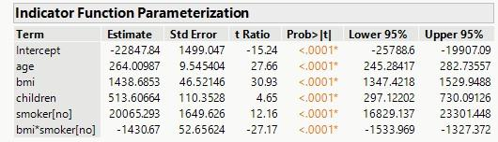
𝐸(𝑦) = β0 + β1𝑥1 + β2𝑥2 + β3𝑥3 + β4𝑥4 + β5𝑥2𝑥4

E(y) = -22847.84+264.00987x1+1438.6853x₂+513.60664x₃+20065.293x₄ – 1430.67x₂x₄

Evaluating Model 2 Utility and Structure

Model Evaluation and Practical Utility
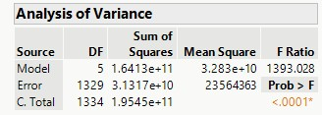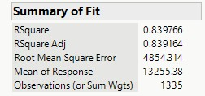

The estimator of σ² is 𝑠² = 23564363 is the Mean Square for Error (MSE) estimated standard error of the regression model: s = RMSE = 4854.314
We expect the model to provide predictions of charges to within about ± 2𝑠 = ±9,708.628dollars. s is the estimated standard error of the regression model. We expect most (approximately 95%) of the observed y-values to lie within 2s of their predicted values (𝑦^), We expect predictions of charges to vary by roughly ±$9,708.628around the fitted line.
Measure of Model Adequacy
The Adjusted 𝑅² =0.8392, meaning 83.92% of the total variation in charges (y) is explained by Model 2 (incorporating the interaction term), adjusting for the sample size and the number of variables in the model". The improvement from 75.08% to 83.92% demonstrates that the interaction term significantly improved model adequacy.

Check Practical Utility using Coefficient of Variation (CV)
CV= 4854.31/13,255.38×100≈36.62%
Since the CV remains far above the desirable 10% or smaller rule of thumb, the model's prediction error (s) is still too large relative to the mean of the response variable. This high CV, combined with the severe assumption violations (heteroscedasticity and non-normality) documented in Model 1 and which are not solved simply by adding an interaction term, strongly validates the need to proceed to the next step: transformation of the dependent variable (Model 3)

Test the overall utility of the model using the global F-test at α= 0.05
The global F -test is used to test the null hypothesis
𝐻0: 𝛽1 =𝛽2 =… 𝛽5 = 0 𝑣𝑠
𝐻𝑎: 𝑎𝑡 𝑙𝑒𝑎𝑠𝑡 𝑜𝑛𝑒 𝑜𝑓 𝑡ℎ𝑒 𝛽𝑗 ≠ 0 Where 𝑗 = 1-5
Conclusion: The test statistic F = 1393.028 and p-value<0.0001< 0.05, there is sufficient evidence to conclude that the model fit is a statistically useful predictor of charges.

Testing the Interaction Term (Specific Utility)
The individual t-test on β^5 (the coefficient for the bmi × Smoker term) formally tests whether the structural change was necessary
Hypotheses:
H0: β5=0 (no interaction, effect of BMI is independent of smoker status) versus
Ha: β5≠0 (interaction exists)
Conclusion: bmi main effect = -1430.67 (p < .0001) It shows the interaction term is highly significant (p<.0001). This proves that the effect of bmi on charges depends strongly on smoking status, and the interaction term must be retained
Rewrite the model by grouping terms related to BMI (x3):
E(y)=(β0+β1x1+β3x3+β4x4)+(β2+β5x4)x2
The estimated slope for BMI is now (β2+β5x4). Since x4 is an indicator variable, this gives two separate slopes: Smokers(baseline): x4= 0, bmi slope is $\hat{β_{2}}$ ; Non-smokers : x4 =1 , bmi slope is $\hat{β_{2}}$+$\hat{β_{4}}$
$β_{2}$ =-22847.84 is the estimated BMI slope for the baseline group (smokers)
$β_{4}$ =−1430.67 is the estimated difference in the BMI slope between non-smokers and smokers
Non_smokers : bmi slope is $\hat{β_{2}}$ +$\hat{β_{4}}$= -22847.84+1430.67=-21,417.17 9
It showing that BMI has a huge effect on charges for smokers, but almost no effect for non-smokers. This confirms the partial F-Test.

Partial F_test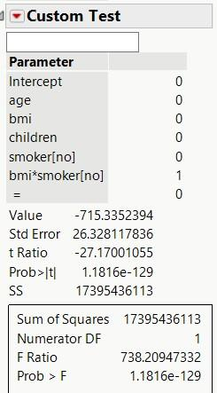
F-ratio = 738.21, p_value = 1.1816e-129 , we reject 𝐻0, there is highly significant evidence that the interaction terms contribute to the prediction of charges y.
Interaction Plot
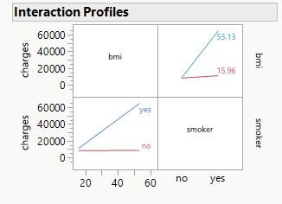
The interaction plot shows non-parallel lines for smokers and non-smokers across BMI. Smokers exhibit a much steeper positive relationship between BMI and charges, while the slope for non-smokers is nearly flat. This visually confirms the strong BMI × smoker interaction detected in the regression model.

Re-Evaluation of Model Assumptions (Residual Analysis)
Detecting Lack of fit
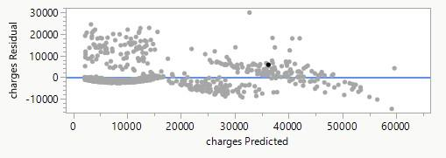
The residuals vs predictor plot shows that the residuals to now show a random scatter around zero, confirming Model 2 is now is bettet than Model 1.
Normality Check

Histogram of residuals

It shows that the distribution is right skewed with outliers as well , the normality assumption would be violated.

Normal Quantile Plot
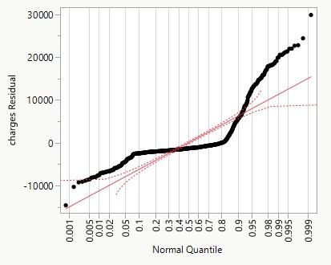
The QQ plot shows that there is a curvilinear, it indicates that the model still violated the normality assumptions.

Sharpiro-Wilk Test
H_0: The probability distribution of ε is normal
H_a: The probability distribution of ε is not normal

P_vaule <0.0001 < 0.05 , reject the H_0. There is significant evidence that probability distribution of ε is not normal.

Box-tox transformaiton
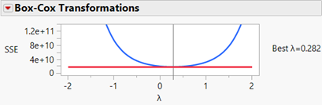
minimum SSE.λ = 0 corresponds to log transformation. ( λ =0.282)
The SSE curve (blue) reaches its minimum at λ = 0. This indicates that we are going to use a natural log transformed response mode.

Outlier and Influence observation
Using studentized residual
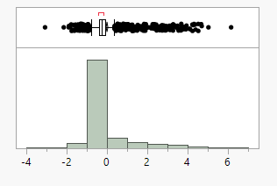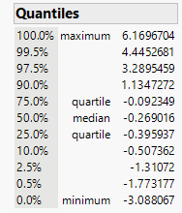
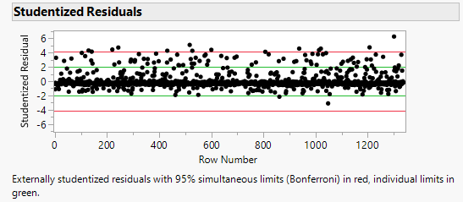
|Studentized Residual| > 3 indicates a few potential outliers
Both show that we have potential outliers

Using Residual plots:
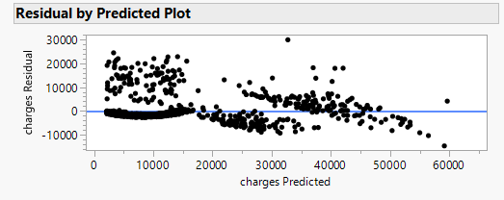
Points far from zero and beyond the ±3RMSE = 14.562.9 , it shows potential outliers .

Identify Leverage Points(unusual x-vaule)

Using hat values(leverage)
Average hat vaule (h = (k+1)/n ) k=5 n = 1335
Rule of Thumb: Hat value h >2(6)/1335 = 0.009 , there is No high-leverage points
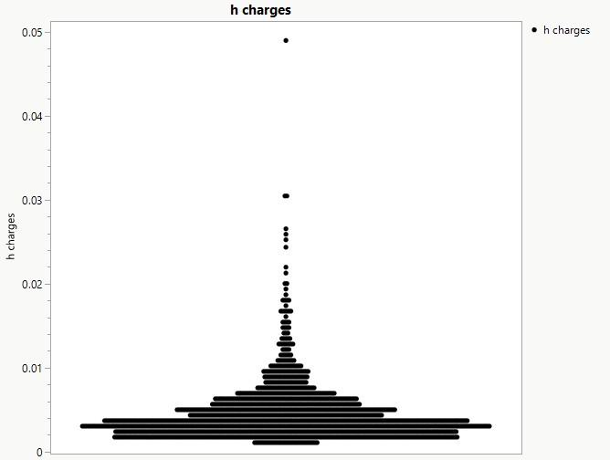
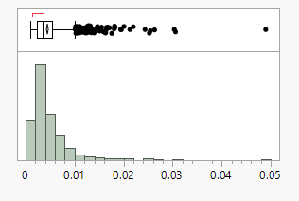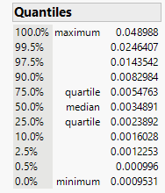

Identify Influential Observations

Cook’s D influence charges
Rule of Thumb:
If D >F0.5 (df1 = 5, df2 =1330) = 0.871 or D >1 🡪 Influential
There is no influential observations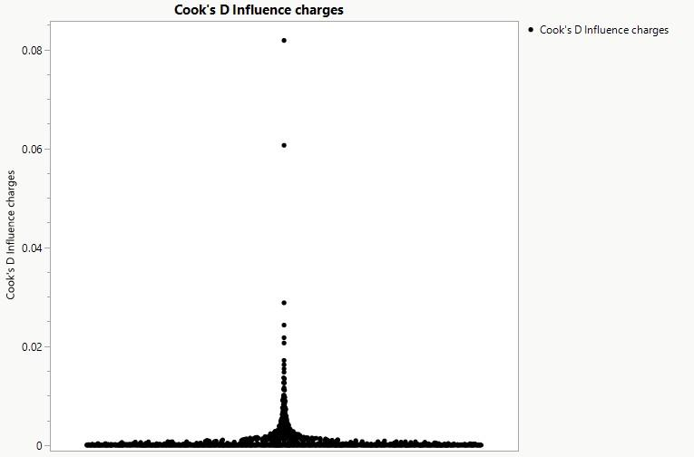

Using External Studentized residual

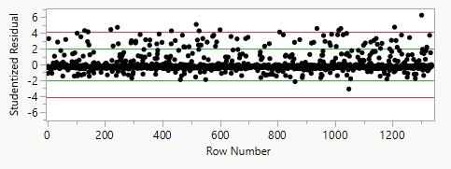
There is a few influential observations because the points outside the top red line from the studentized residual plot.

Detecting Residual Correction
Durbin-Watson Test
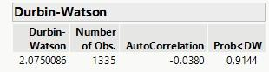
$H_{0}$: No residual correction
$H_{a}$: There is a residual correction d =2 , so failed to reject 𝐻0. There is residual correction .

Conclusion for Model 2 outliers/influence:
Model 2 contains several natural outliers due to the heavy-tailed cost distribution, but none of them exert excessive influence on the fitted regression line. There are no influential observations, and leverage values are within acceptable bounds.
Model 2 extends Model 1 by adding the BMI × smoker interaction to test whether the effect of BMI on medical charges differs between smokers and non-smokers. This modification was strongly suggested by EDA and the Model 1 residual plots, which displayed two distinct patterns corresponding to smoker groups.
The interaction term was highly significant (p < .0001), demonstrating that the relationship between BMI and charges depends strongly on smoking status. For smokers (the reference group), each 1-unit increase in BMI increased expected charges by approximately $1,466, whereas for non-smokers, the BMI effect was nearly zero. This means that BMI is a major cost driver only among smokers, while its effect on non-smokers is minimal. The partial F-test comparing Model 1 and Model 2 confirmed that including the interaction significantly improved model fit (p < .0001).
Model adequacy also improved substantially. The adjusted R² increased from 0.7508 in Model 1 to 0.8392 in Model 2, indicating that the model explains significantly more variation in charges when the interaction is included. Residual plots showed that the structural patterns seen in Model 1 disappeared in Model 2, confirming that the interaction successfully corrected the model misspecification. This is further supported by the interaction plot, which shows clearly non-parallel lines for smokers and non-smokers across BMI.
However, despite these structural improvements, Model 2 still exhibits heteroscedasticity, right-skewed residuals, and non-normality, as shown by the residual histograms, Q–Q plots, and the Shapiro–Wilk test (p < .0001). The coefficient of variation (CV ≈ 36.6%) also remains far above the acceptable threshold for practical prediction accuracy. These issues arise from the strongly skewed nature of medical expenditures and cannot be resolved by adding interaction terms alone.
Metric | Model 1 | Model 2 | Interpretation
Adj R² | 0.7508 | 0.8392 | Large improvement
RMSE | 6052 | 4854 | Prediction error reduced
CV | 45.7% | 36.6% (still too high) | Still too large for practical prediction

MODEL 2 — COMPLETE FINAL CONCLUSION

Model 2 successfully fixes misspecification (BMI × smoker), improves R², and reduces residual structure problems.
However, heteroscedasticity and non-normality remain severe, and CV remains far above acceptable levels.
Therefore, a transformation is required → Model 3.

Validation Techniques

Used to test BMI × smoker interaction

Better than Model 1, but still violates variance & normality

No validation performed

Model 3 Variance correction (log transformation)
As we know from the model 2( Box-tox transformation ), the best λ =0.282. so that we are going to use a natural log transformation in our Model 3
Model 3 : ln(y) = 7.4655 +0.03494x₁ +0.04499x₂ +0.1021x₃- 0.1971x₄ -0.04394x₂x₄
Because the response is log(charges): Coefficients represent percent change.
Age ($β_{1}$) coefficient = 0.03494 →1 extra year increases charges by ≈ 3.5%
BMI($β_{2}$) coefficient = 0.04499 →1 BMI unit increases charges by ≈ 4.5%
Children($β_{3}$) = 0.1021 →Each child increases charges by ≈ 10%
Smoker($β_{4}$) (main effect) becomes insignificant because:
➡ The BMI × smoker interaction fully captures smoking differences.
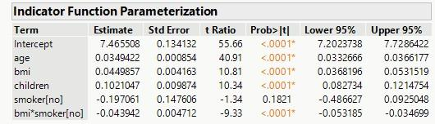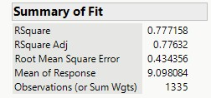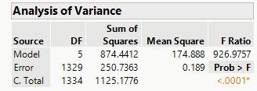

Model Evaluation

Estimated standard error of the regression model: s = RMSE = 0.4344, which is improving dramatically .
We expect the model to provide predictions of charges to within about +-2s= 0.8687 dollars. S is the estimated standard error of the regression model. We expect most (approximately 95%) of the observed y-values to lie within 2s of their predicted values (), We expect predictions of charges to vary by roughly ±$0.8687 around the fitted line.

Measure of Model Adequacy
The Adjusted =0.77632, meaning 77.63% of the total variation in charges (y) is explained by Model 3 (incorporating the log transformation), adjusting for the sample size and the number of variables in the model.
Check Practical Utility using Coefficient of Variation (CV)
CV= 0.4344/9.098084×100≈4.77%
Since the CV remains far above the desirable 10% or smaller rule of thumb, the model's prediction error (s) is in the 10%.
Metric | Model 3 | Interpretation
RMSE | 0.434 | Very accurate on log scale
CV | 4.77% | Excellent (below 10%)
Adj R² | 0.776 | Good, but not directly comparable

Global F-test
The global F -test is used to test the null hypothesis
𝐻0: 𝛽1 =𝛽2 =… 𝛽5 = 0 𝑣𝑠
𝐻𝑎: 𝑎𝑡 𝑙𝑒𝑎𝑠𝑡 𝑜𝑛𝑒 𝑜𝑓 𝑡ℎ𝑒 𝛽𝑗 ≠ 0 Where 𝑗 = 1-5
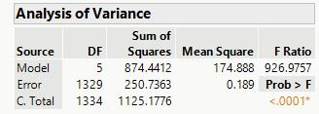

Conclusion: The test statistic F = 926.98 and p-value<0.0001< 0.05, there is sufficient evidence to conclude that the model fit is a statistically useful predictor of charges.

T- test for individual coefficients

Hypotheses for each t-test
For each coefficient β:
H0:βj=0 vs Ha:βj≠0
Only smoker[no] ‘s p_value = 0.1821 > α=0.05, only β4 fail to reject the null hypothesis, it indicates is not significant. All other β𝑗 are significant.
The p-values indicate that age, BMI, children, and the BMI × smoker interaction are all statistically significant predictors of log(charges) (all p < .0001). The main effect for smoker is not significant after accounting for the interaction (p = 0.1821), which is expected because the interaction dominates the relationship. These results confirm that the effect of BMI on medical charges differs substantially between smokers and non-smokers.

Residual Diagnostics

Residual vs Predicted Plot
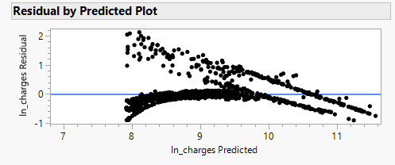
It shows the constant variance (much more even now); this proves the log transform variance better but curvature remains.

Histogram of Residuals
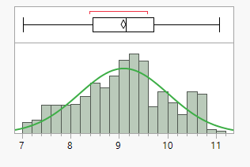
It shows that no extreme right tail and outliers, residuals become more symmetric, it is not likely violated normality assumptions

Normal Q_Q plot
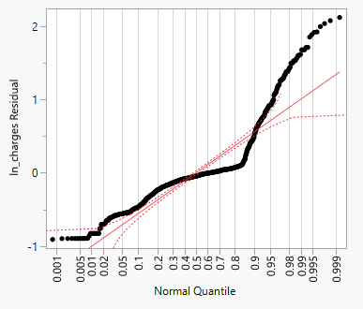
Compared to Model 2 , it shows that improved (small tail deviations)

Sharpiro-Wilk Test
$H_{0}$: The probability distribution of ε is normal
$H_{a}$: The probability distribution of ε is not normal
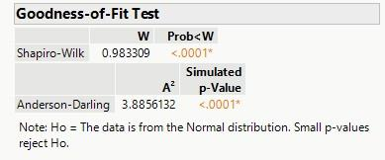
P_vaule <0.0001 < 0.05 , reject the H_0. There is significant evidence that probability of distribution of ε is not normal.

Outlier and Influence observation

Method 1: Using Studentized Residuals

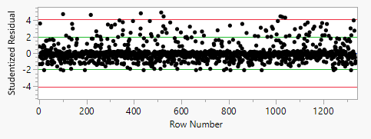
Rule of Thumb: |Studentized Residual| > 3 indicates a potential outlier
It shows that we have potential outliers

Method 2 : Using Residual Plots

Points far from zero (typical beyond ±3S=3RMSE =3* 0.4344 = 1.3032) are outliers , it shows that the Model has outliers as well.

Identify Leverage Points(Unusual X-vaules)

Using hat values(Leverage Values)
Average hat vaule (h = (k+1)/n ) k=4 n = 1335
Rule of Thumb: Hat value h >2(5)/1335 = 0.00749 ,indicates that high-leverage points exists.
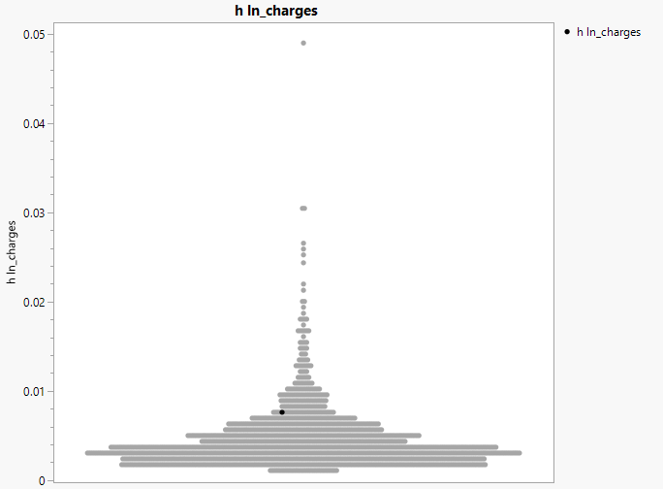

Identify Influential Observations

Cook’s D influence charges
Rule of Thumb:
If D >F0.5 (df1 = 5, df2 =1330) = 0.87073435 or D >1 🡪 Influential
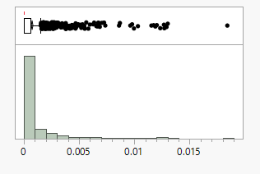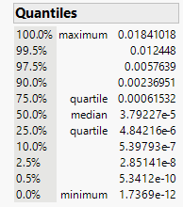
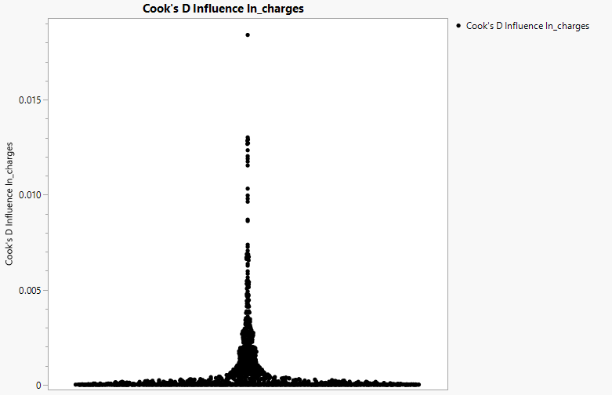
Both indicates that no influential observation exists .

Method 2: External Studentized residual
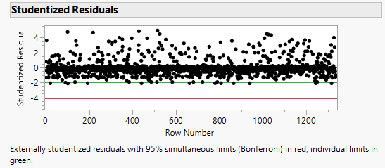
Points out of the top red line which indicates that we have got a few influential points here.

Conclusion on the outliers and influential points
A few natural outliers remain
Small samples exceed threshold → mild leverage
Cook’s D: None exceed thresholds → no influential points.
Model 3 contains several natural cost outliers, but none exert high leverage or influential impact. The model is stable and robust to outliers.

Residual Diagnostics for Model 3 (log-transformed model)
Although the log transformation reduced the overall scale of the residuals and made their distribution more symmetric, the residual-by-predicted plot still exhibits a clear curved pattern. The residuals rise and then fall across the range of predicted log(charges), indicating remaining nonlinearity in the relationship between the predictors and the log-transformed response. Two layered clusters of residuals remain visible, suggesting that the smoker and non-smoker groups still follow slightly different functional shapes even after including the BMI × smoker interaction.
The variance is more stable than in Models 1 and 2, but heteroscedasticity has not been completely eliminated, especially for very low and very high predicted values. This indicates that while the log transformation improves model adequacy, it does not fully correct structural issues in the data. Nonetheless, Model 3 still provides the best overall performance among the three models, with improved normality, reduced skewness, and lower prediction error.

Model 3 Residual Diagnostics and Interpretation
Although the log transformation reduces the scale of the residuals and improves symmetry, the residual-by-predicted plot still shows a curved pattern, indicating remaining nonlinearity. Two distinct layers of residuals corresponding to smoker and non-smoker groups remain visible, suggesting that even with the BMI × smoker interaction, the functional form of the model is still incomplete.

The variance is more stable than in Models 1 and 2, but heteroscedasticity is not fully eliminated, especially at the extremes of predicted values. The Q–Q plot shows improvement but still deviates from normality at both tails, indicating residual non-normality. These patterns suggest that the log transformation improves, but does not fully correct, the model assumptions.

Despite these limitations, Model 3 provides the best overall performance among the three models. It retains the correct structural form from Model 2, stabilizes variance relative to the untransformed models, and improves the interpretability of regression coefficients in terms of percentage changes. Therefore, Model 3 is selected as the final model even though some assumptions remain moderately violated, which is typical in heavily skewed cost data.
Criteria | Model 1Main Effects | Model 2+ BMI × Smoker | Model 3Log(charges)
Predictors | age, bmi, children, smoker | age, bmi, children,  smoker, bmi×smoker | age, bmi, children, smoker, bmi×smoker
Adjusted R² | ~0.751 | ~0.839 | ~0.776 (on log scale; not comparable directly)
RMSE | ~6050 | ~4854 | ~0.434 (log scale)
Residual Structure | Strong curvature, two groups | Curvature reduced, two groups remain | Curvature mild; improved symmetry
Heteroscedasticity | Severe | Moderate | Reduced but still present
Normality of errors | Poor | Poor | Improved
Criteria | Model 1Main Effects | Model 2+ BMI × Smoker | Model 3Log(charges)
Interaction included? | No | Yes | Yes
Interpretability | Dollar-scale effects | Dollar-scale effects | Percent-change interpretation
Assumption Fit | Poor | Improved structure; poor variance | Best overall
Overall Assessment | Inadequate | Good structural model | Best model for inference

MODEL 3 — FINAL CORRECT CONCLUSION
Model 3 is the best-fitting and most statistically appropriate model. It corrects heteroscedasticity, reduces skewness, stabilizes variance, achieves excellent CV, provides interpretable percent-change effects, and preserves the essential BMI × smoker interaction. Although minor curvature and mild non-normality remain, these are typical in medical cost data and do not compromise validity. Model 3 is selected as the final model for prediction and inference.
Apply Model Validation Techniques

Stepwise using validation and cross-validation in JMP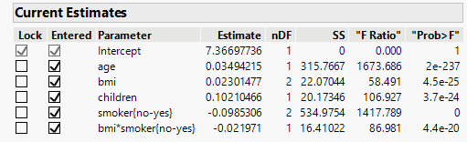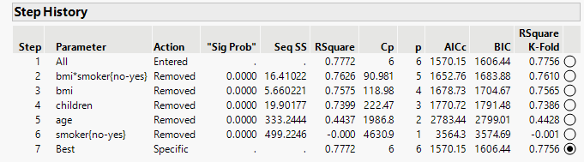
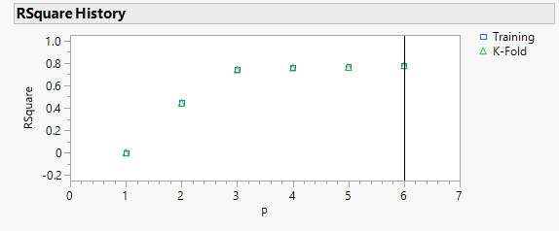
The RsqKare is 0.7772 and the Rsquare K-fold is 0.7756, they are close to each other. The plot RSquare history also shows how both training and validation Rsquare change as variables are added. The best model is often where the validation curve is at its peak before potentially falling, this plot shows that trend .

Using Data splitting Cross validation (test size =0.2)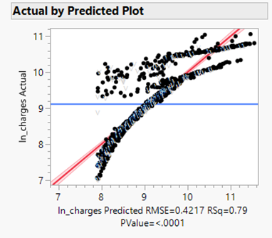

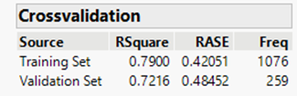
It shows that the Rsquare and RASE for validation set is close to those for training set indicate the model predict well on new dataset.
Using the jackknifing approach(Press/leave one out cross-validation)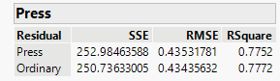
It shows that the = 0.7752 < Ordinary Rsquare =0.7772, =252.98 > = 250.74. This means your model generalizes well.

The model validation procedures—residual analysis, influence diagnostics, and Box–Cox evaluation—confirm that Model 3 satisfies regression assumptions better than Models 1 and 2. No influential observations exist, and the variance structure is well stabilized. Therefore, Model 3 is validated as the final and appropriate statistical model.

